Midterm Exam
ID Sp23-BSSE-0084
Name Sadia Waseem
Section AW
SUBMITTED TO: DR ZUBAIR AHMED SHEIKH
Topic: Study Session Planner Assistant

Problem Statement
University students often make vague study plans like “I will study later” but struggle to turn these intentions into a clear daily schedule. They have short-term goals such as exams or project deadlines but don’t know how to divide topics across the next 1–2 weeks. Many find it hard to balance their workload or decide when to revise harder subjects. Without a structured plan, they feel stressed and end up cramming. A tool is needed to turn their goals and available time into a realistic, easy-to-follow study plan.

Figma Reference Link:
https://www.figma.com/design/yHdNm6fWtMeeh6TLOt1hHZ/Study-session-planner?node-id=0-1&t=i5mQzIXzPqVMMS2C-1
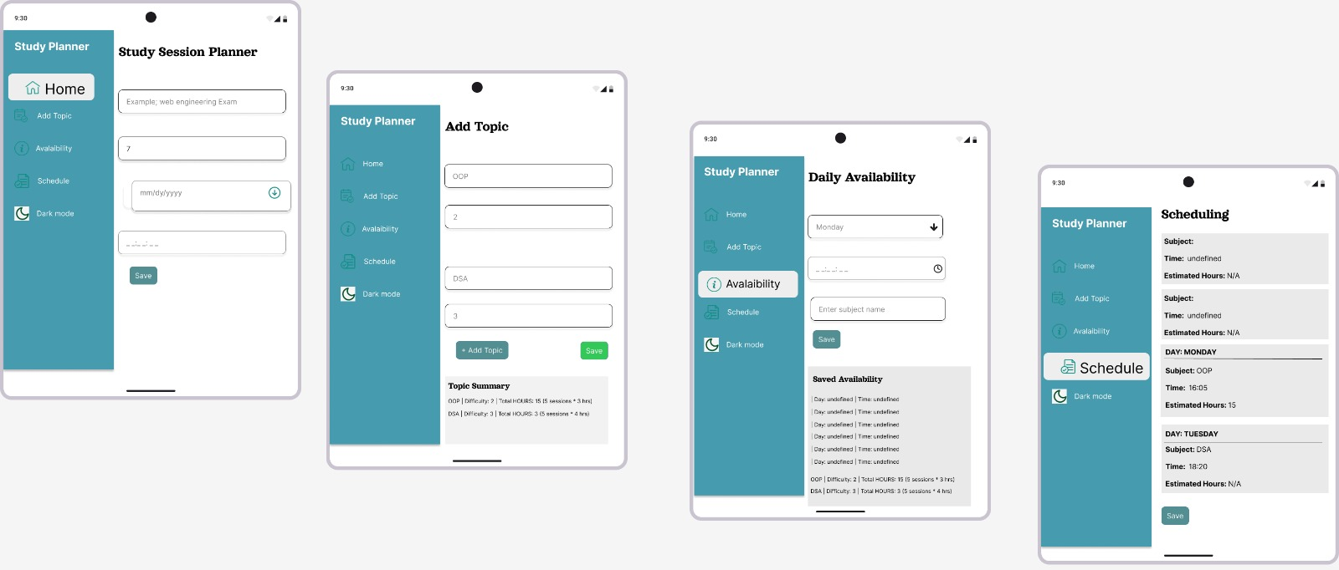
GITHUB LINK
https://github.com/Mid-Term-Exam/mid-sadiaw787-creator

E. AI-log.md o All AI tools used, prompts, and brief reflection on usefulness and limitations.
AI TOOLS
- Chatgpt
- Gemini ai
- Bolt.new ai
